**CTF Topic: Identifying JavaScript Vulnerabilities with Retire.js**



**1. Introduction**



Retire.js is a tool used to detect the use of vulnerable JavaScript libraries in web applications. It helps developers and security professionals identify and mitigate potential security risks arising from outdated or vulnerable JavaScript code.

**2. Tools and Requirements**

Google Chrome browser  
Install the [Retire.js Chrome extension]

**3. Scenario**



As a participant in this CTF challenge, your task is to use the Retire.js Chrome extension to identify vulnerabilities in the JavaScript libraries used on `http://testphp.vulnweb.com/`. Perform the analysis and answer the following questions based on your findings.

**4. Process to follow while performing CTF**

Step1: Install the Retire.js Chrome extension from the provided link: [**https://chromewebstore.google.com/detail/retirejs/moibopkbhjceeedibkbkbchbjnkadmom**](https://chromewebstore.google.com/detail/retirejs/moibopkbhjceeedibkbkbchbjnkadmom)  
Step 2: Visit **http://testhtml5.vulnweb.com/#/popular** and use the extension to analyze the JavaScript libraries and identify any vulnerabilities.

**Questions and Answers**

Flag 1: What is the strap version found?

Answer: 2.3.1

Flag Captured.

Flag 2: How many bootstrap were there before 4.0.0 is end-of-life and no longer maintained.

Answer: 72

Flag Captured.

**Hint**

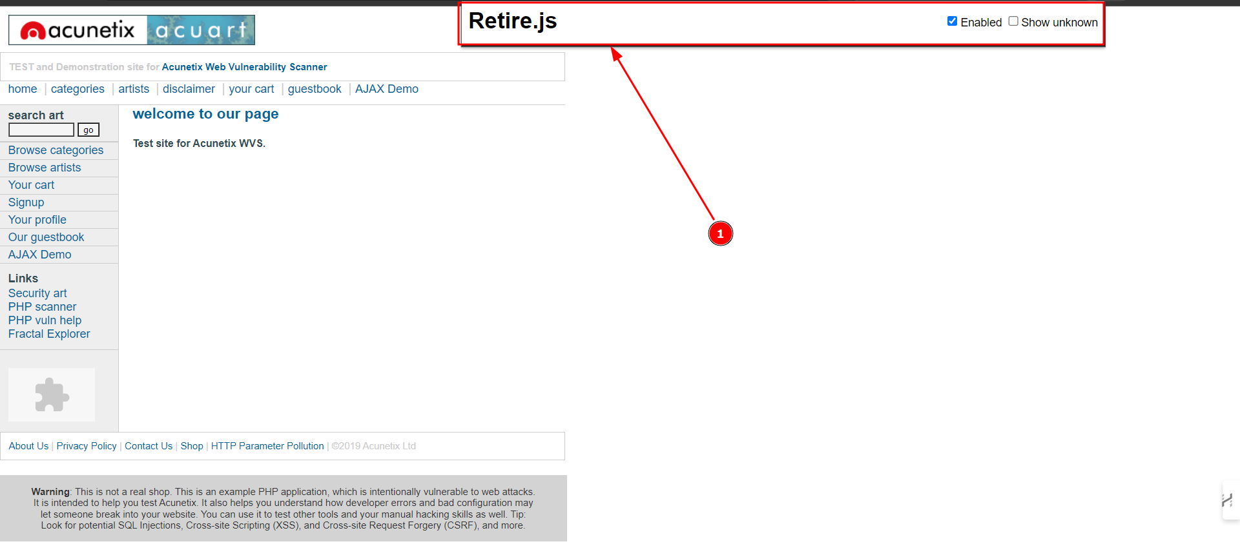

Use the Retire.js Chrome extension and carefully examine the results for `http://testphp.vulnweb.com/`. Look for any outdated or vulnerable JavaScript libraries and follow the extension's recommendations for mitigating identified vulnerabilities.

